# Colors:



Body text color: #48758a



Banner background-color, background color for content: #d1f3fd



Nav background-color: #9ecddf



Nav text color, H1 text color, H2 text color : #105781



Nav hover text color: #e7f8ff

I originally chose my colors to have a monochromatic theme on my website so that the colors would not distract too much from the content. I chose the main colors to be light blue to convey a calm and fresh feel. While I like these colors, I am on the fence about changing them due to competitor designs. Most photographers who are targeting the same or similar audiences as me have muted neutral colors like beige or brown. I am not sure I want to follow that because I really dislike the whole beige trend that is happening but I also know that the website must appeal to the target audience to be successful. I think I will continue with these colors for now and maybe change them later if I can find something I like.

# Typography:

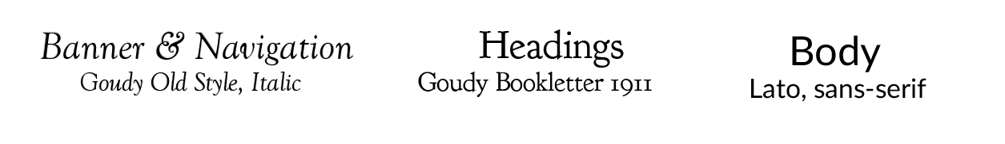

I like the Goudy Bookletter 1911 and Lato, sans-serif for their purposes, but I may change the Goudy Old Style to something else later. I am currently creating a monogram that I plan on using as a logo on my website so I may find a font that better complements my monogram when it is ready to be used on the website. I may have some difficulty as I have drawn my monogram by hand so there may be fonts that closely resemble my monogram but are unlikely to match completely.